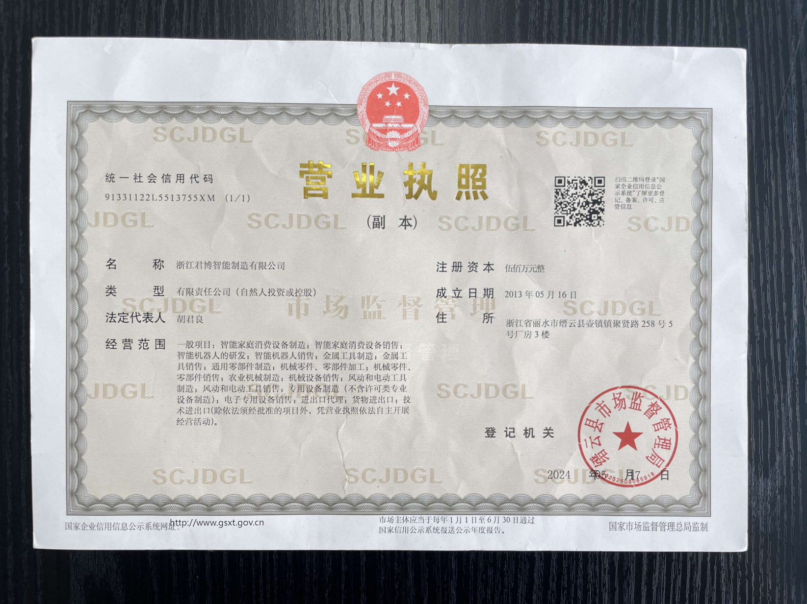
Business License

Registered Number: 【营业执照号码】
The Enterprise Name:
【公司名字拼音】
Business Type: Limited
Address:【公司地址拼音或英文】
Person in Charge: 【法人名字拼音】
Date of Set-up:【成立日月年或者年月日】
Notes
- The Business License is the legal certificate for the corporate capacity of the enterprise and its legal operation.
- The Business License shall be put on the place of the office where it can be seen.
- The Business License is not allowed to be forged, altered, rent, leased or transferred.
- Any registration item changed, it shall apply with the original authority to do the changes, and get a new Business License.
- The company shall attend the annual survey on any date between 1 January and 30 June.
- When the Business License is canceled, any business activities not concerning the liquidation shall not be allowed.
- When the cancellation procedures going on, the original and duplicate of the Business License shall be returned.
- If the Business License is lost or damaged, the company shall make a statement of invalidation in the newspaper designated by the original authority, and then apply a new one.

Registration authority 【城市拼音】 administration for industry and commerce 【签发日月年】

